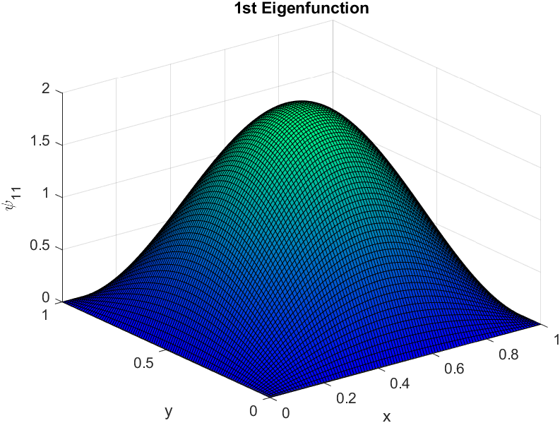

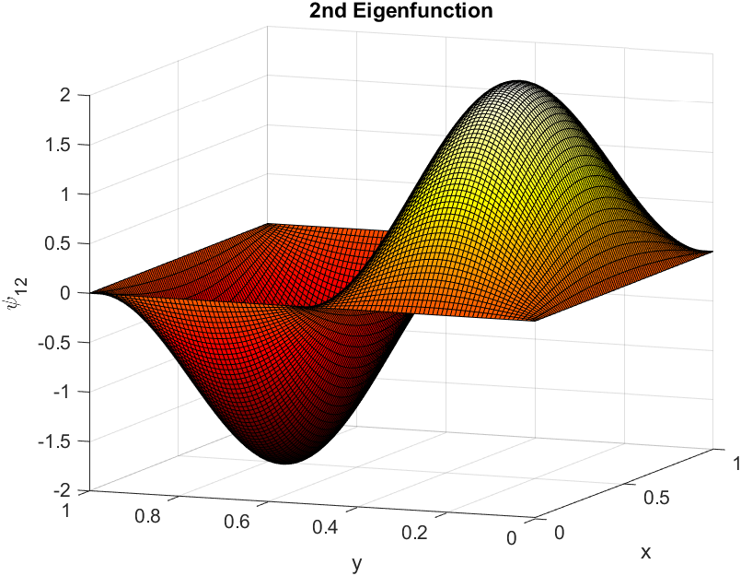

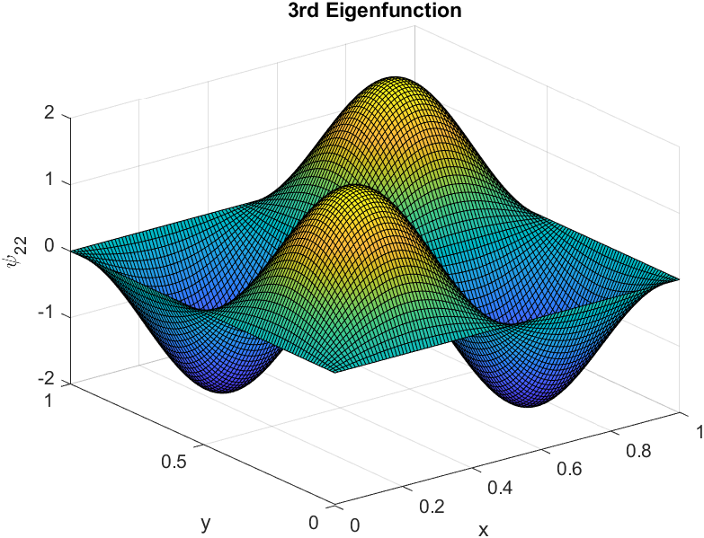

MATLAB CODE FOR PART 1

%parameters

a = 1.0; % length of the box

[x,y] = meshgrid(0:0.01:1,0:0.01:1);

psi_11 = (2/a).*(sin(1.*pi.*x/a)).*(sin(1.*pi.*y/a)); %first eigenfunction

psi_12 = (2/a).*(sin(1.*pi.*x/a)).*(sin(2.*pi.*y/a)); %second eigenfunction

psi_22 = (2/a).*(sin(2.*pi.*x/a)).*(sin(2.*pi.*y/a)); %third eigenfunction

figure

z1 = surf(x,y,psi_11);

colormap(winter);

title("1st Eigenfunction");

xlabel("x"),ylabel("y"),zlabel("\psi_1_1");

figure

z2 = surf(x,y,psi_12);

colormap(hot);

title("2nd Eigenfunction");

xlabel("x"),ylabel("y"),zlabel("\psi_1_2");

figure

z3 = surf(x,y,psi_22);

colormap(parula);

title("3rd Eigenfunction");

xlabel("x"),ylabel("y"),zlabel("\psi_2_2");